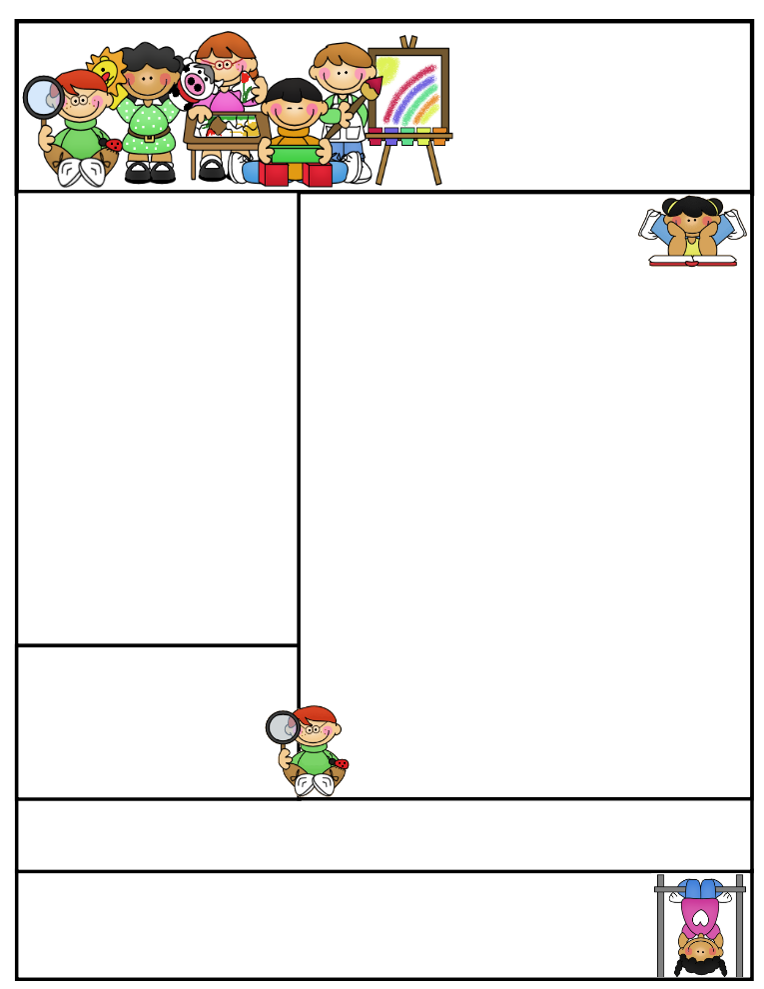

**Allen Jay Elementary Pre-K**

Ms. Evans & Ms. Dorta

Oct 22, 2018

**Contact Information:**

**Kimberly Evans**

**School:**

**(336) 434-8490 ext1663**

**Email:evansk3@gcsnc.com**

Sajood Oct 13th

Jacqueline 23rd

**Contact Information:**

**Nikkia Mack School:**

**(336) 819-2935**

**Email:**[**mackn@gcsnc.com**](mailto:jessupk@gcsnc.com)

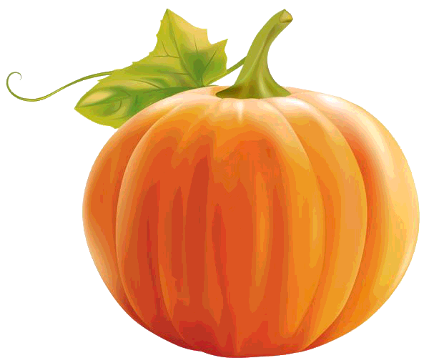

**THIS WEEK**

**Creative Curriculum: What do we know about trees? What do we want to find out? What are the characteristics of trees in our community?**

**Fundations: Letters Kk & Ll**

**Second Step: Identifying Feelings**

[](http://www.google.com/url?sa=i&rct=j&q=&esrc=s&frm=1&source=images&cd=&cad=rja&uact=8&ved=0CAQQjRw&url=http://classroomclipart.com/clipart/Clipart/Animals/Squirrel_Clipart.htm&ei=gJRKVO_2HsvBggSCsoHYCA&bvm=bv.77880786,d.eXY&psig=AFQjCNFudHhbcMHNGoeYNcO01SSiOhOBsQ&ust=1414260224544508)**QUESTION OF THE DAY:**

**Mon/Tues-Which of these comes from a tree?**

**Wed-What do you think we’ll find under the trees on our site visit tomorrow.**

**Thur-How does this feel?**

**Fri-Which smells best to you?**

Allen Jay News

Thank you so much to all of you who came to the fall festival. It was a great success due to the hard work of our PTA, teachers, and volunteers including the students from Southern Guilford High School.

This week we will be celebrating our Red Ribbon Week as a symbol of our commitment towards being drug free.

On Monday, shine bright and stand out- wear pink and black and/or something with sparkles

On Tuesday, Orange you glad you don't do drugs? - wear orange

On Wednesday, Be strong- wear your superhero shirt or cape

On Thursday, Take care of yourself- wear your PJs day

On Friday, Turn your back on drugs- wear your hat and shirt backwards

**Dates to Remember:**

**\*Scholastic Book Form due on Oct 31st.**

**\*Reading Logs due on Oct 31st**

**\* Parent/Teacher Conferences at school Nov 2-8th.**

**\*November 13th- Field Trip to the Greensboro Children’s Museum**

Weekly Newsletter

sletter



**Charlie- Jan 7**

**London- Jan 12**

**Ms. Davis -Jan 13**